Watershed Watch 2020 Week 2 - Glenwood Bridge with USGS
TEMPERATURE: The temperature of the Boise River is an important indicator of health. When temperatures get too warm, it increases the likelihood of harmful algae blooms, chemical reactions, and is dangerous for fish. Scientist monitor the temperature in the river constantly. This data helps us learn what normal temperatures should be and can show us where there might be problems in the river. Temperature is measured in °C or °F. The following graph shows temperature over a few days on the Boise River near Caldwell, ID. Notice that the temperature changes during the night and day times. Temperature is usually measured with a thermometer.
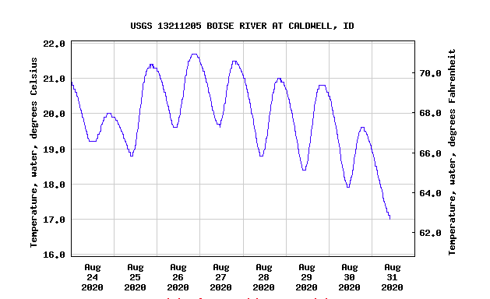

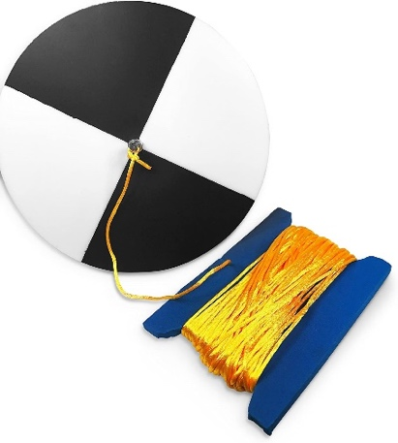
TURBIDITY: Turbidity is a measure of water’s lack of clarity. It is used as an indicator of water quality. Certain aquatic organisms cannot survive if the turbidity is too high. Turbidity is measured in NTUs (Nephelometric Turbidity Units). If the river has high turbidity, that means that there are a lot of particles floating in the water. These particles can be things like soil, organic matter, chemicals, salts, nutrients, and more. Some rivers naturally have high turbidity, like the muddy Mississippi River. Organisms in high turbidity rivers have adapted to living in those environments. Other rivers have lower turbidity. These rivers, like the Boise River, are usually filled with cold, clear water and organisms in them are adapted for those conditions.
In order to measure turbidity, scientist use a secchi disk. A secchi disk is a special black and white disk on a string the you can lower into water until you cannot see it. Once you cannot see it, you slowly pull it up until you can barely see it, then measure how deep the secchi disk went into the water. Multiply this number by 2 and then you will know how far light is penetrating the water. Check out this video to see a secchi disk in action! https://www.youtube.com/watch?v=IGcYV_PjP2k

What about in flowing water? In rivers, we can’t always lower a secchi disk into the water so we have to use a turbidity tube, which is a plastic tube you can fill with water, and it has a secchi disk at the bottom. Another method is to use a device called a spectrophotometer, these are generally used when a scientist needs to know what kind of light a sample of water is absorbing.

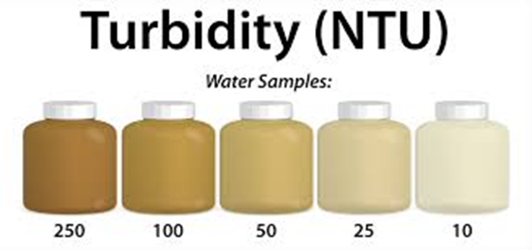
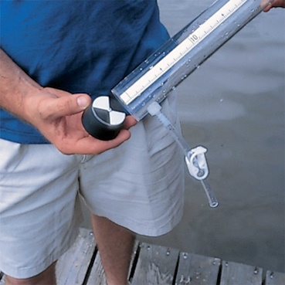

Turbidity is measured in NTUs. NTU stands for Nephelometric Turbidity Units. When NTUs are higher the water is murky, when lower, the water is clearer. Pristine lakes and rivers usually have NTU levels <5.
A scientist showing the secchi disk on the bottom of a turbidity tube.

Temperature and Turbidity Worksheet and Activity
Name____________________________________ Date_______________

Let’s complete some temperature and turbidity challenges!
Challenge 1:
Look at the two pictures below. One picture shows a river with 4 NTUs in turbidity, the other river has a measured turbidity of 80 NTUs. Fill out the picture captions with the correct data.
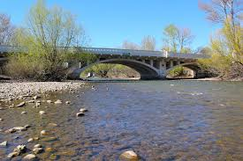
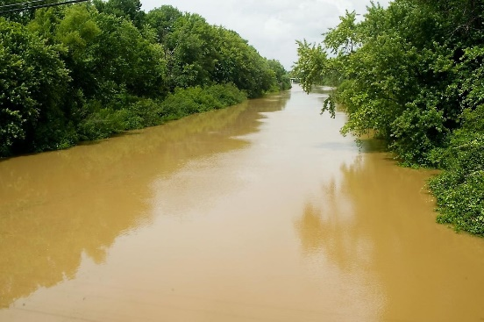

The Boise River in Idaho has a measured turbidity of ______NTUs
The Big Muddy River in Illinois has a measured turbidity of _______NTUs

How can you tell which river has 4 NTU measured turbidity and which river has 80 NTUs of measured turbidity? What types of adaptations would animals in the Big Muddy River need to have to survive? What types of adaptations would animals in the Boise River need to have to survive?

Challenge 2:
Find a good temperature and turbidity habitat for Idaho fish.
Some fish like to live in cold water, and some can live in warmer water. There are many types of fish that live in the Boise River. Let’s look at three of them and some of their temperature and turbidity preferences.

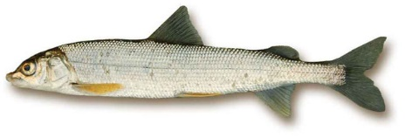 | 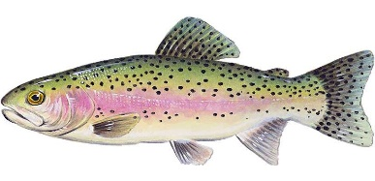 | 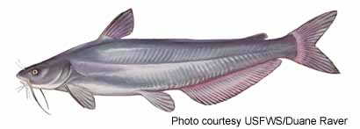
MOUNTAIN WHITEFISH  These great fish are native to the Boise River. They tend to live on the bottom of pools that form under riffles in rivers. They like to eat aquatic insects. They prefer clear water that they can see insects in, and they can live comfortably in summer temperature from 16°C - 20°C. They like larger parts of the river. | RAINBOW TROUT  These trout are native to Idaho and a very popular species of fish to fish for. They eat insects and prefer cool, clear water. Their preferred summer temperature is around 16°C | BLUE CATFISH  Catfish are not native to the Boise River, but have been brought to the Boise River by people. They can live in muddy, murky water and like summer temperatures around 22°C - 26°C.

Now that you have an idea about what some Idaho fish need to live healthy lives, lets look at some of the data collected from the Boise River this summer. The following data shows the temperature measurements and the turbidity measurements from the beginning of the lower Boise River Watershed to the end of the Boise River where it runs into the Snake River. The site codes are labeled on the graphs and you can see where they are located with the Watershed Watch Map.

- Which sites offer ideal temperature and turbidity for the following fish species?
Mountain Whitefish:

Rainbow Trout:

Blue Catfish:

Challenge 3:
We want you to go to the river and discover some temperature and turbidity. If you can’t get to the river, that is ok! We have a link you can follow that will show you a video of the river and you can answer the same questions.
Link to video
Question 1:
Is the water that you are looking at clear (low turbidity) or murky (high turbidity)? How can you tell?

Question 2:
If you put your hand in the water (or imagine putting your hand in the river) does it feel warmer or colder than the air? Why do you think it is colder than the air?

Question 3:
Does the water you are looking at seem healthy? Why or why not?

