Week 4: Organisms in the River with the City of Boise
Scientists spend a lot of time figuring out the best way to test water to see if it is healthy. They can test physical parameters like temperature and turbidity (how clear is the water), and chemical parameters like pH and dissolved oxygen in the water. In water bodies that move very slowly like lakes and ponds, these physical and chemical parameters are very important. In water bodies that move more quickly, like rivers and streams, physical and chemical parameters are still important, but scientists need to look at other factors too. Since the water they are testing is constantly moving downstream, they need to utilize living things that do not, or cannot, move very far in the water body to get an idea of the water quality over time. These living things are biological parameters that we consider bioindicators. This means that we can use what we know about these organisms to help us understand the water quality in a river or stream over time. Scientist can use plants that grow in water or periphyton (the slimy stuff growing on the bottom of streams and rivers) as bioindicators, but today we are going to talk about bioindicators called macroinvertebrates.

Macroinvertebrates
The term “macroinvertebrate” or “macro” for short, is used to describe any living organism that you can see with the naked eye (macro) and does not have a backbone (invertebrate). In rivers and streams, macroinvertebrates come in many different forms. Some of those forms are:
- Insects: there are many different insects that live in the Boise River. A lot of these insects spend a large part of their lifecycle under water. Some of these insects live their entire life under water. When we are looking for insects in the Boise River, we are trying to find organisms life mayfly nymphs, caddisfly nymphs, or stonefly nymphs. These nymphs are very sensitive to pollution so when we find them, it indicates good water quality. Other insects we can find are different beetles, mosquito larva, and more.
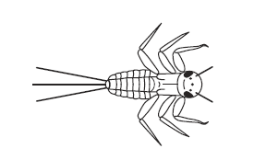
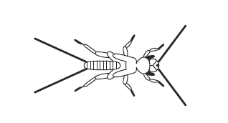

Stonefly Nymph
Mayfly Nymph
- Mollusks: There are many mollusks that can live in the Boise River. Mostly these mollusks are types of snails and mussels. Some native mussels can be incredibly rare and valuable for our river’s water quality since they can filter up to 15 gallons of water in a single day!
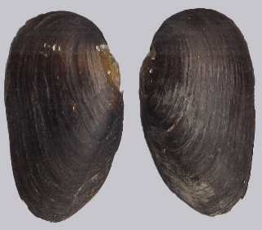
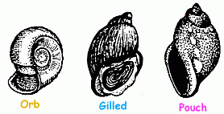

Snails
Freshwater Pearl Mussel

- Crustaceans: Crustaceans are an important part of the Boise River Watershed. They consist of the crayfish and the amphipods that live in our waterways.
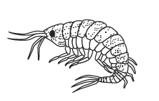
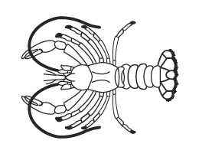

Scud or amphipod
Crayfish

Activities for Week 4

Activity 1: Research a Macro
Look up a macroinvertebrate that lives in the Boise River. Answer the following questions about the macro:
- How big is the macro?
- What does the macro eat?
- Where does the macro like to live?
- Is the macro sensitive to pollution?
- What is the name of the macro?

Activity 2: Make your own Macro
Making your own macro is a fun activity! It is fun to think about crazy designs, but you also want to think about the science behind macros and what features could make your macro successful in an aquatic environment. Plan out your macro with the following questionnaire and then draw or paint it. Be sure to send us copies of the macros you create to bw@cityofboise.org so that we can see them!
- Where do you want your macro to live?
- What do you want your macro to eat?
- How will it catch or get its food?
- How big is your macro?
- What color is your macro?
- How will your macro defend itself?
- What is the name of your macro?

Activity 3: Use an index to determine water quality
At the Boise WaterShed Education Center, we have developed a simple index so that you can perform biological testing on the river. We want you to go out to the river (always go with an adult) and see what you can find. Watch the informational video here and use our River Macro ID chart to help identify macros and to help determine the water quality in the Boise River.
If you cannot get to the Boise River, that is ok! Below you can find different macro samples taken from two different rivers and you can use the River Macro ID chart to determine which one is the healthiest and which one may have some pollution in it.
Is River number 1 or River number 2 healthier based on the bioindicators? How do you know?

River 1
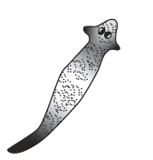
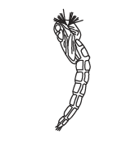
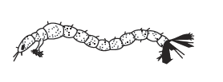
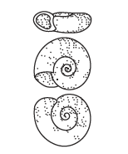
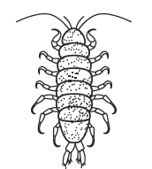
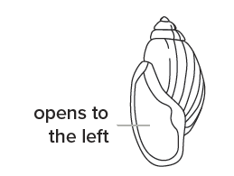
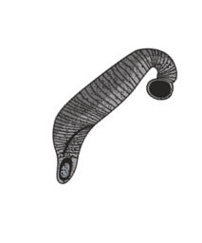
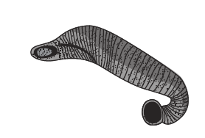

River 2
