Week 5: Nutrients with the City of Boise
Nutrients are an important part of life. They provide the nourishment that living things need to thrive. In river ecosystems, they are essential for the well being of the organisims. Plants, animals, bugs and microbes all need nutrients. Two of the most common and imporant nutrients that can be found in water systems are phosphates and nitrogen. Phosphorus (phosphates) is a chemical element that is essential for life. It is a key part of DNA. Nitrogen (nitrates) is a highly abundant element that is also essential for life. Both of these nutrients are found in our own bodies and all around us. In river ecosystems, there are always phosphates and nitrates. However, scientists are constantly testing for these nutrients since too many phosphates and nitrates can be a source of pollution in our rivers.
When there are too many minerals and nutrients (like phosphates and nitrates) in the water, it speeds up a process called eutrophication. Eutrophication is when bodies of water have excess nutrients. These excess nutrients cause algae to grow rapidly in the water. The water can become green, smelly, and eventually it could kill many of the organisims that are living in the water body. Some water bodies are in a process called natural eutrophication; places like swamps and ponds are eutrophic and that is the way the ecosystem is supposed to be. Many water bodies like lakes and streams, are not naturally eutrophic. Unforntuately, people sometimes add pollution in the form of nitrates and phosphates that put water bodies through a process called cultural eutrophication. This means that water bodies which shouldn’t be eutrophic are becoming eutrophic due to human pollution.
In the Boise River Watershed, scientists are constantly checking the amounts of nutrients that are in the water. This information can help them understand what kind of pollution we might be adding to the Boise River and what we might have to do to minimize our effect on the water quality. Additionally, high levels of nutrients can lead to harmful algea blooms. These harmful algea blooms consist of cyanobacteria (blue-green algea). Cyanobacteria are actually a bacteria that can photosyntesize like algea. These bacteria can be incredibly poisionus to humans and animals, which is another reason why we want to make sure the nutrients in our water bodies are controlled.

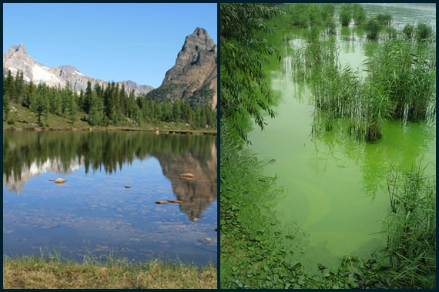
The left side of this picture shows a clear, mountain lake. The right side shows a highly eutrophic lake. Notice the difference?

Activities for Week 5

Activity 1: Search for eutrophication using Google Earth.
See if you can find examples of eutrophication on Google Earth. A great way to look for signs of eutrophication is to look at satellite images of bodies of water. These images can often show algal blooms and green water. Look up at least three lakes or rivers and compare the way the water looks. Make sure to vary the location of the bodies of water that you look up, try and find ones close to human civilization and ones further from human influences.

Activity 2: Search for phosphates in your home.
In order to minimize the impact of phosphates, we need to stop using so many of them in our homes. Do a phosphate audit of some of the products you have in your house. A good place to look for phosphates is in cleaning products and some personal care products. Phosphates can also be found in some foods. Usually phosphates are labelled on the ingredients list of the products label. They can be written as orthophosphates, pyrophosphates, polyphosphates, and others, but usually will have “phosphate” in the name. After you have identified some products that contain phosphates research some phosphate free alternatives that you can use in your home.

Activity 3: Lets look at some data!
The following graph shows total phosphorus data from the Boise River this August. Look at the graph and answer some questions below:

Use the Boise Watershed Site map from the resource section to help answer questions about this graph.
- How does the amount of total phosphorus change as we move down the Boise River?

- Why do you think that change happens?

- What are some of the problems that might happen due to high levels of phosphorus in the lower Boise River Watershed?

- What are some ways we could lower the amount of phosphorus in our river?

