Week 6: Environmental Engineering with the City of Caldwell
We often think about engineering devices, buildings, and electronics, but we rarely think about how environments (especially ones with a lot of humans in it) need to be engineered for the safety and health of humans and nature. Environmental Engineering is a branch of engineering which focuses on improving the environment and protecting people from pollution, flooding, and more! Since so many people live around the lower Boise River, there are a lot of Environmental Engineers who work on the river for us.
Like scientists, engineers must be smart, and ready to tackle challenges. Instead of focusing on observations and discoveries, engineers are the people who create solutions to our challenges. They rely on scientists to provide them with good information so that they can create effective solutions. Engineers use the Engineering Design Process to create solutions to problems. Check out the engineering design process below:
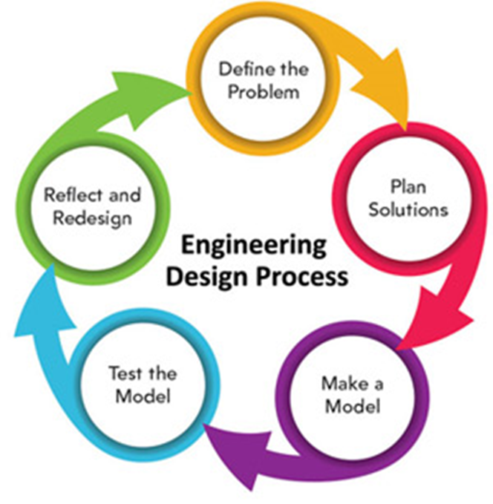

Define the problem: Figure out what issue you are trying to solve! Write it out clearly so you know exactly what needs to be fixed.
Plan solutions: Engineers spend a lot of their time writing down and planning solutions. Before committing to a specific solution, you need to make sure that it is the best one! This requires a lot of time and research.
Make a model: Engineers can’t create a solution without building a model of it first! Types of models include diagrams, drawings, physical replicas, mathematical representations, analogies, and computer simulations.
Test a mode: Testing your model is one of the most important steps of the engineering design process. Make sure to record everything and take notes.
Reflect and Redesign: Take what you know and design the best solution possible, if you must go back to the beginning of the process, that is great! Engineers are always refining and redesigning their work.

Activities for Week 6

Activity 1: Build a paper bridge challenge
Engineers generally must work within parameters. This means that they only have so many resources available to design a solution. We are going to give you an engineering challenge with set parameters. Your goal is to build a sturdy bridge that crosses at least 8 inches. You can create a valley or space to cross by using books, chairs, tables, etc. It may sound easy, but you can only use ONE piece of paper to build this bridge, and it needs to be able to support the weight of at least 50 pennies (or 125 grams if you don’t have pennies). Good luck and remember to use the engineering design process to help you complete this challenge.

Activity 2: Design an engineering solution for the Boise River
Throughout Watershed Watch you have learned about some of the impacts humans have on the Boise River. One of the biggest impacts is the stormwater that flows from the streets of cities into the river. This challenge is going to ask you to do two things. Firstly, research stormwater and its impacts on rivers. Some good local resources are the Partners for Clean Water and the Idaho Department of Environmental Quality. Next, develop a plan for how cities can minimize stormwater impacts. Make sure to write out details and draw out what your plan would look like. If you can, build a model of your plan.

Activity 3: Environmental Engineering search
Go outside and search for some examples of environmental engineering. We are not as trained to see environmental engineering as we are other types of engineering but look for places that have erosion control (Tip: You’ll see this near a construction site.), stormwater drains, parks, flooding controls, paver parking lots, swales, etc. Write down some of your observations so that you can catalog different types of environmental engineering.

