Week 7: Rules and Regulations with the Department of Environmental Quality
Before the mid-1900s, people dealt with pollution differently than today. In the USA and in Idaho, it was common practice to put used chemicals, human waste, waste from industry, and more into rivers or lakes. Due to this practice, our freshwater systems became some of the most polluted places in the world. In Idaho, the Boise River was so dirty that people downstream from Boise could not fish or swim in the river and many of the river organisms were dying. In the rest of the United States, rivers like the Boise River were extremely polluted. People knew that something had to be done about pollution in the water. In Boise, the League of Women Voters got together and raised funds to build the Lander Street Water Renewal Facility. This facility would treat used water from the city before releasing it back into the Boise River. It was built in 1949 and is still operating today!
In the rest of the country, people were getting concerned about pollution in water. On June 22, 1969, the Cuyahoga River in Cleveland, Ohio caught on fire due to the amount of pollution floating on its surface. This fire gained national attention and inspired the creation of the Clean Water Act of 1972. The Clean Water Act has gone through many updates and changes in the last 50 years but simply put, it is a law that sets pollution limits for things discharged into water bodies. It also sets limits for how healthy water bodies need to be in the USA. The Clean Water Act, along with other regulations, is monitored by the Environmental Protection Agency (EPA) and state-run departments. In Idaho, the Department of Environmental Quality (DEQ) is the entity that monitors rivers and lakes to make sure that Idaho follows the Clean Water Act. If an organization or community thinks they need to discharge water back into rivers or lakes, they must apply to the EPA for a National Pollutant Discharge Elimination System (NPDES) permit. When they apply for this permit, they will clearly show the ways they will clean the water before discharging it back into water bodies in order to avoid polluting the water. After they receive the NPDES permit from the EPA, then they can start discharging reclaimed water into water bodies. In Idaho, the DEQ monitors all of the NPDES permit holders to make sure they are keeping their promise to protect the waters in our state. In the USA our goal is for everyone to have “fishable, swimmable, and touchable” water.

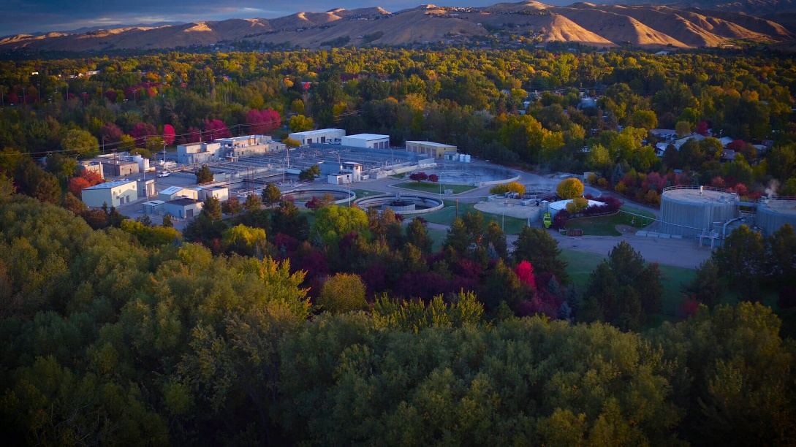
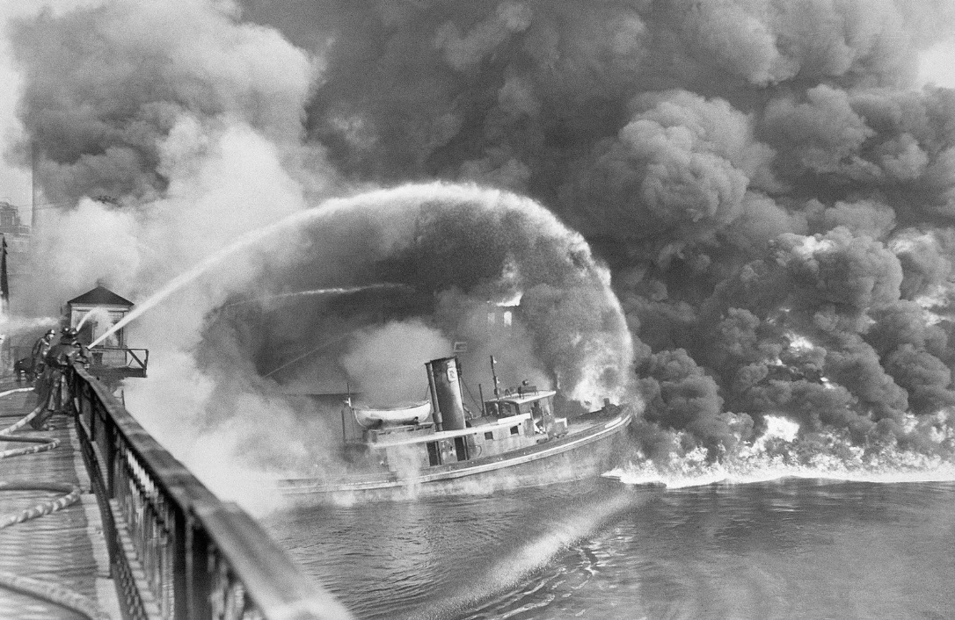
A current picture of the Lander Street Water Renewal which was built in 1949 to help protect the Boise River.

The Cuyahoga River burning in 1969. This is the most famous incident on that river since it inspired the Clean Water Act, but this river had caught on fire more than 13 times due to pollution.

Activities for week 7

Activity 1: Take a virtual tour of the West Boise Water Renewal Facility
Join one of the Boise WaterShed’s staff as they take you on a tour of the West Boise Water Renewal Facility and show you how the city of Boise protects the Boise River and meets its NPDES permit requirements.
https://www.youtube.com/watch?v=aifTQn-gACE

Activity 2: Make a regulation
Creating regulations is a difficult process. Often, groups that are in charge of creating regulations have to juggle what is good for the health of the river, what is good for the economy, and what is good for the people that rely on the river. For this activity, take some time to think about a problem that you want to fix on the Boise River. It could be the amount of trash, the smell, the pollution in the river, anything that matters to you. Finally, take some time to create a regulation that would help solve the problem. Answer the following questions:

- What is the problem you want to fix?

- Why is it important to you?

- Why is it important to people who live in the Treasure Valley?

- What regulations would you create to fix the problem?

- What agency(s) or organization(s) would oversee monitoring and enforcing your regulation?

Activity 3: Think of the River!
We know that there are organizations and groups that are regulating and protecting the river from pollution, but how can you help protect the river? Use the link below and look at the suggested actions which can lower the amount of pollution that you create. Try and complete one of these actions so that you can be an active protector of our water quality! https://kids.nationalgeographic.com/explore/nature/save-the-earth-hub/13-ways-to-save-the-earth-from-pollution/

