Watershed Watch Week 3: Invasive Species
Our world is more connected than ever. We send planes, ships, products, people, and animals to new countries and new places every day. One of the consequences of this connectivity is the introduction and the spread of invasive species. Invasive species are plants, animals, or pathogens that are brought to a new area and harm other plants and animals. Often, they overtake and “invade” areas that historically were occupied by native or more beneficial species.
We talk a lot about invasive species in Idaho because we live in a state with vast natural resources. These natural resources (think: water, timber, minerals, and more!) are the economic core of our state. What protects our natural resources are healthy ecosystems. Healthy ecosystems clean our water, grow resources, clean our air, protect us from flooding, and more. These benefits of healthy ecosystems are called ecosystem services. When an invasive species is introduced into a healthy ecosystem, it can (and often will) overtake the ecosystem. Invasive species will replace the native and non-invasive species and inhibit the ecosystem’s ability to provide ecosystem services. Idaho’s ecosystems are in a constant battle to fend off invasive species, and they cannot do so without our help!
The next page shows some common invasive species you may find in the Boise River Watershed.

Invasive Species in the Boise Watershed

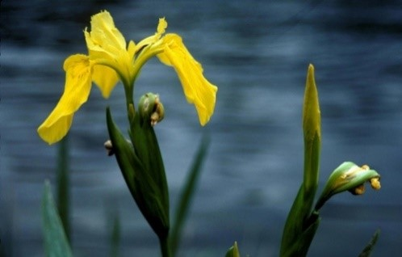  Yellow Flag Iris | 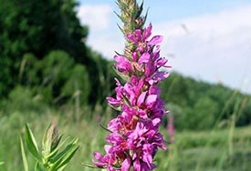  Purple Loosestrife | 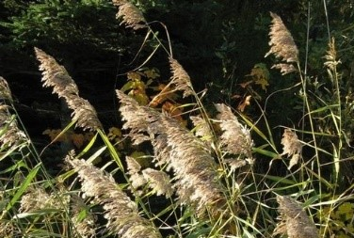  Common Reed
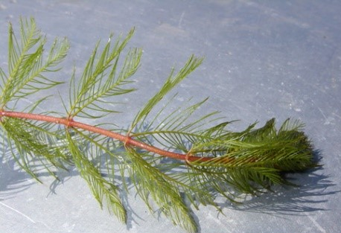  Eurasian Watermilfoil | 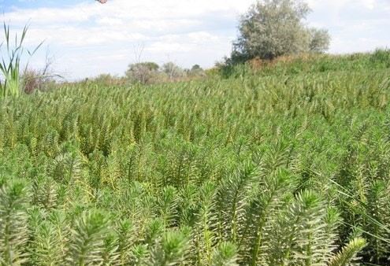  Parrotfeather Milfoil | 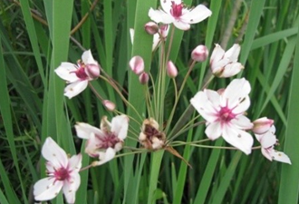  Flowering Rush
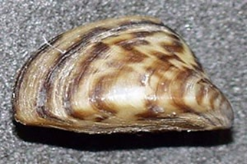  Zebra Mussel | 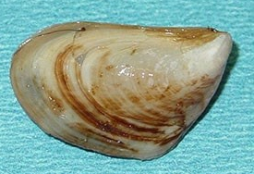  Quagga Mussel | 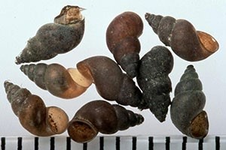  New Zealand Mud Snail

What can you do?
There are a lot of things that we can do to prevent the spread of invasive species in Idaho. The best place to find information on invasive species is the Invasive Species of Idaho webpage: invasivespecies.idaho.gov.
There, you can look up different invasive species and find information on how you can help control them based on your interests. Here are some examples:
- When you visit outdoor spaces, make sure you clean your boots, clothes, and pets. Invasive weeds and seeds can hitch a ride on you and your pets.
- When you purchase plants online, make sure they are native species to grow in our region.
- If you go fishing or camping near water, make sure to clean off your gear.
- Do not transport firewood long distances.
- Never release pets into the wild.
As someone that lives in the Boise River Watershed, being on watch for suspicious looking plants and critters is extremely valuable for the invasive plant managers in the state. When you find an invasive species or something that might be invasive, you can take pictures of it, and contact the Idaho Invasive Species Hotline 1-877-336-8676, or visit invasivespecies.idaho.gov/contact to find someone in your area who can help.

Activities for week 3

Activity 1: Identify some invasive species:

Look at the following pictures of invasive species and see if you can identify them. Use invasivespecies.idaho.gov for help identifying these invasive species.
Answers for Activity 1:

A.
Poison Hemlock D. American Bullfrog

B.
Giant Hogweed E. Red Eared Slider

C.
Yellow Floating Heart F.
Hydrilla

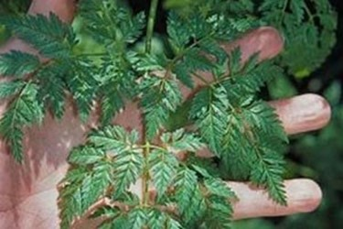 | 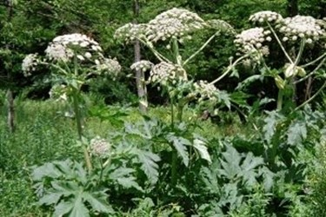 | 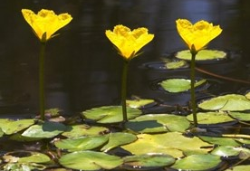  B  A  C
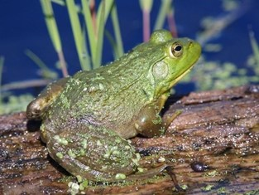 | 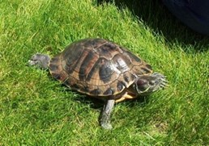  F  E  D | 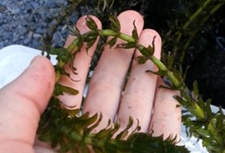

Activity 2: Research an invasive species
Find and invasive species in Idaho and answer the following questions:
- What is it called?
- Where is it from, originally?
- How does it move to new areas?
- What does it do to healthy ecosystems?
- How can we manage it?

Activity 3: Search for invasive species in the Boise River Watershed
Spend some time searching for invasive species in the Boise River Watershed. Remember to search safely, do not go too close the river and do not touch plants that appear prickly and unsafe.
If you think you have found an invasive species, the best thing to do is
- Record its location
- Take pictures of it
- Call the Invasive Species Hotline 1-877-336-8676.

